Bioviratech – Business Plan 2022

Table of Contents
1.0 Introduction to the company 3
1.1 Keys to Success 3
1.2 Vision of the company 4
1.3 Mission of the company 4
1.4 Target Market 5
1.5 Service Offering 6
2.0 SWOT analysis 7
3.0 VRIO analysis 8
4.0 Market Overview 9
4.1 Political 9
4.2 Economic 9
4.3 Social 10
4.4 PESTEL analysis of the UK 11
5.0 Industry Analysis 13
6.0 Marketing Plan 16
6.1 Brand identity 16
6.2 Website 17
6.3 Social Media 17
6.4 Advertising 18
6.5 PR and Influencer marketing 19
6.6 Opening/Re-launch marketing strategies 19
8.0 Investors List 19
Contatc Info 21

Introduction to the company
Bioviratech is a unique biotech company which merges the worlds of vaccines, blockchain, international law, and smart contracts to form a mutually beneficial system. Bioviratech seeks to work with multiple entities, with high emphasis on pharmaceutical companies. We provide tokens to the consumers in order for them to receive a vaccine in the future. The token can be purchased for $1.00 and be bought for multiple people such as family members or friends of the customer. By virtue of the token, the customers are entitled to primary access, of a vaccine, to a future pandemic after the most vulnerable are given emergency vaccines. This does not include the cost of the vaccine, but during COVID many had the cost but couldn’t gain access. Moreover, the tokens are tradable using the Crypto structure.
The idea of Bioviratech is to minimise the imbalance of vaccine distribution which often implies that developing countries are given less access to vaccines and they risk higher negative economic and health conditions. By offering these tokens, the customers become entitled to primary access, to a vaccine, for a future pandemic.
The business shall be run on the basis of sustainability and will offer a distinctive experience to the customers. Additionally, the company seeks to form a healthy relationship with all its stakeholders, specially the pharmaceutical companies to form a sustainable business which adds value to the society.

Keys to Success
The keys to success of the brand are defined below:
• Providing a convenient and affordable way to purchase token for customers.
• Having a high quality marketing setup which enhances the brand awareness in a quick period of time.
• Establishment of a customer base which is familiar with Cryptocurrency and seeks to form a benefit off it.
• Expanding business to different areas of the globe.
• Establishing long lasting relationship with key stakeholders such as governmental agencies, pharmaceutical companies, and Crypto platforms.

Vision of the company
Millions of people across the world will have contracts giving them reasonably priced and timely access to a vaccine of a future pandemic, regardless of their countries supply by:
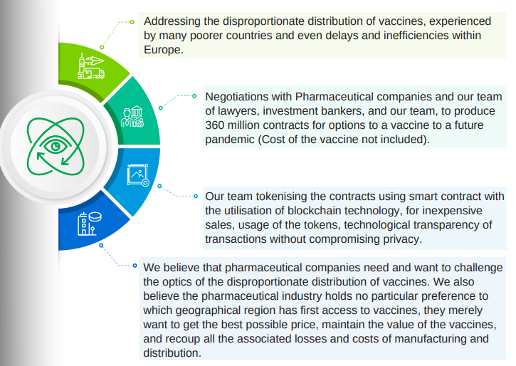

Mission of the company
Give anyone in the world, especially the most financially insecure, the opportunity to purchase privileged future vaccine access by:
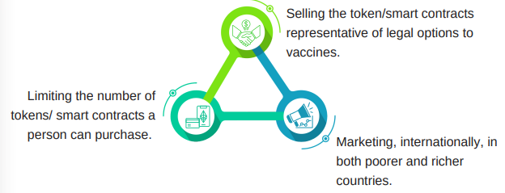

Target Market
Table 1 shows the target market for the company, which is determined through the segmentation analysis.
Table 1 - Segmentation analysis.
Segmentation Bases |  | Targeted Customers
Geographic | Regional | Global
 | Density | Urban and Suburban
Demographic | Age | 21-50
 | Gender | Any
 | Social Status | Lower, Middle and Upper class.
 | Size of family | Individuals, couples, and extended families
 | Income | Low to high income
 | Livelihood | Professionals, students, bachelor stage, and married couples.
Psychographic | Lifestyle | Explorer, reformer, mainstream.
 | Characteristics | Is a digital native and understands technology such as blockchain. Is concerned about future wellbeing from pandemics or disease outbreaks. Cannot afford expensive treatment options from diseases. Is an active user of digital platforms or gadgets. Is familiar with the basics of trading or is an expert.
Behavioural | Attitude | Easy going, experimenter, and determined.
 | Benefits | Guaranteed vaccination, high Quality services, and self-expression.
 | Persistence | Regular or irregular buyers.

Service Offering
The services offered by the brand are discussed below.
Table 2 - Product Offering
Bioviratech BVT
A sample customer lifecycle is portrayed in the corresponding image. | 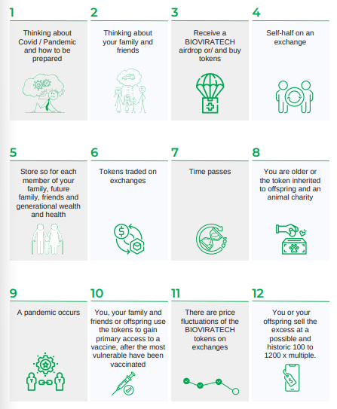

2.0 SWOT analysis
Table 3 - SWOT analysis.
Strengths | Weaknesses
- The entrepreneur is highly competent in conducting such business operations due to familiarity in the industry.  - A unique business idea which is bound to gain a high customer volume due to the application on general public.  - A sustainable system which is securely operated without the hassle and costs of a big brick and mortar presence. | - Low budget presently for an effective market penetration; however, it can be addressed through external investment.  - Low marketing expertise, yet appropriate steps are identified, and digital marketing can be used for effective market penetration.
Opportunities | Threats
- The company can use relatively new marketing measures such as social media to make a quick mark on the target population and establish the brand for higher reach.  - The rising usage of crypto based websites, and the gradual normalcy of cryptocurrency is a positive sign.  - The company can use the service offerings to quickly establish their mark on low-income countries and regions, thus gaining access to developing markets with high economic potential. | - Even though the company is one of the first movers in terms of merging the aspects of blockchain and pharmaceutical companies; however, presence and dominance of established cryptocurrency can be threat.  - There is still a significant amount of population globally, often referred to as ‘anti-vaxxers’, who may pose a threat to the nature of the business. However, with the evident efficiency of vaccines against Covid-19, the company has a strong basis for such operations.

3.0 VRIO analysis
Table 4 - VRIO Analysis.
Resources | Value | Rare | Imitation | Organization | Competitive advantage
Access to products | Yes | Yes | Yes | Yes | Providing string competitive advantage
Position in the industry | No | No | Yes | Unexplored to date | Can provide sustainable competitive advantage
Marketing expertise | No | No | Yes | Unexplored to date | Not significant in providing competitive advantage
Distribution channel | Yes | Yes | No | Yes | Sustainable competitive advantage
Opportunities for extension | Yes | No | Yes | Yes | Can prove to be a significant challenge to expand.

4.0 Market Overview
Even though the operation is meant to be global, yet the starting point shall be the United States and the UK; thus, the market overview is conducted by considering political, economic, and social aspects of operations in the United States, and the PESTEL analysis in the UK.

4.1 Political
USA has a strong democratic setup and effective rule of law, with elections that are considered fair and transparent. The country enjoys massive political and economic influence over both national and global policymaking and is recognized as the leading superpower in the world. The political stability of the country ensures that businesses such as Bioviratech operate with certainty. Furthermore, the country enjoys positive relationship, specifically Canada, and economic powers such as the UK and Germany, this aspect can provide opportunities of quick future growth.
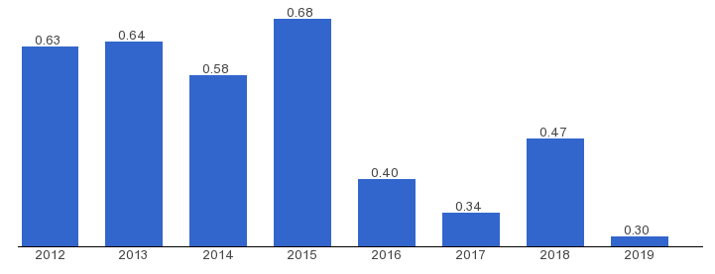
Figure 1 - Political stability index of USA.

4.2 Economic
Firstly, the USA has the biggest economy in the world, which attracts businesses all over the world, and provides the country with very high business confidence. Even though the country has struggled with Covid-19 implications, yet the economy has stabilized to a great extent. The last reported GDP growth rate was 6.4% which is encouraging for start-ups, accompanied with the high demand of services such as vaccines and cryptocurrency, the opportunity for financial growth seems beneficial for the company. Furthermore, the interest rate in the country has dropped in recent times down to 0.25%, this can be beneficial for the company, as it can borrow more funds with ease, for advancing its operations. Even though there are issues such as rising inflation, which may impact the consumer buying power; nonetheless, the stability offered by the overall business and market conditions are highly attractive.

4.3 Social
USA is one the most populous countries in the world, while it has a very highly diverse population. Such elements signify that the company can offer a range of products/services to a wide array of customer base to enhance its growth. Further, it is recognised that many consumers, especially young ones in the country are increasingly becoming attracted to services such as offered by the company; this is a positive indicator for the company. Furthermore, environmental activism is on the rise in the USA, this can be a positive opportunity for the brand in terms of using sustainable measures and promoting it to gain a positive brand image. Moreover, it is found that the internet penetration in the country has accelerated in recent times, which provides an opportunity to actively promote the brand online and conduct other business operations online with ease.
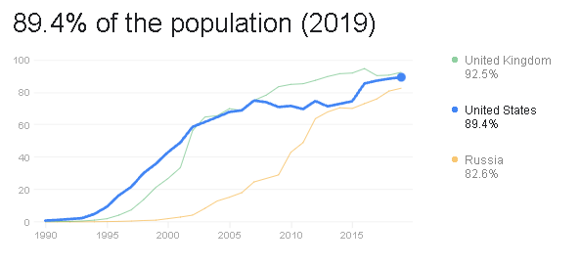
Figure 2 - Internet Penetration.

4.4 PESTEL analysis of the UK (but incorporated in Lithuania)
Table 5 - PESTEL analysis of the UK.
Political | - The UK has a stable political stability, while it also ranks well in the corruption index. This finding states that the company would operate under certainty in the UK, where issues such as unjust taxation or bribery may not be applicable.  - BREXIT is a sensitive political issue which has caused political uncertainty especially with the EU which is supposed to be the biggest import market of the UK. Thus, the vaccine supply from the UK can be impacted negatively due to this aspect. However, the government is actively seeking solutions, and positive results are inevitable.
Economical | - Even though Covid-19 has strongly impacted the UK, it still remains a relatively stable economic region which is expected to counter the issues occurred.  - It is recognised that the UK offers low interest rates to the businesses which is highly positive as it can displays an opportunity to borrow more funds.  - The UK’s exchange rate is superior to that of the US Dollar; this can be positive in the long run since trade is highly involved in terms of e-commerce business.
Social | - Because of Covid-19 the web-based businesses have seen a boost, as individuals will undoubtedly utilize the mediums available. Numerous clients remain utilizing the e-commerce business platforms or crypto based websites, adding chance of development for the organization.  - The high population of the country, and the incredible amount of diversity present is a big opportunity for the company, as it can offer a range of products that can satisfy multiple customer segments.
Technological | - The incredible penetration of internet and mobile usage is a big opportunity for businesses such as Bioviratech. The country is also equipped with highly competent technological infrastructure which can benefit the nature of the business.
Environmental | - The UK is actively working to reduce Environmental waste, including minimising CO2 emissions. Therefore, the company is bound to follow some strong regulations in this regard.
Legal | - Equality Act 2010 is necessary for the company to follow which entails that the company cannot discriminate against any race, gender etc., before, during or after employment.  - Moreover, laws such as UK Employment Act 1996 also makes the company subject to follow laws pertaining minimum wage and leaves etc.

5.0 Industry Analysis
Firstly, it is found from figure 1, where a survey conducted reported that the cryptocurrency users have mostly increased in the countries, many of whom are developing countries. This finding indicates that the venture is suitable in terms of expanding the reach of vaccines through cryptocurrency, as the growth in usage is evident in majority countries.
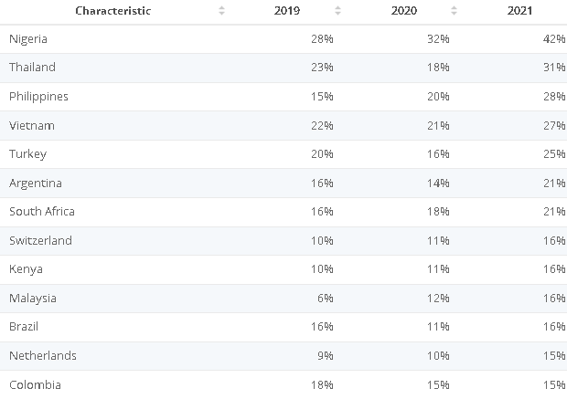
Figure 3 -Share of respondents who indicated they either owned or used cryptocurrencies in 56 countries worldwide from 2019 to 2021.
There are nearly over 10,000 as of 2022 (as shown in figure 4) - a severe increase from just a handful of digital coins in 2013. Note, however, that a large portion of these cryptocurrencies might not be that significant. Due to how open the creation process of a cryptocurrency, it is relatively easy to make one. Indeed, it is believed that the top 20 cryptocurrencies make up nearly 90 percent of the total market.
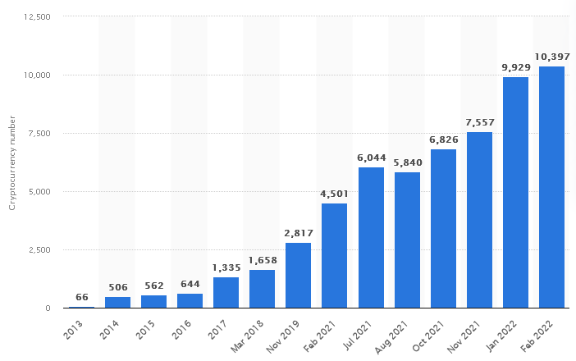
Figure 4 -Number of cryptocurrencies worldwide from 2013 to February 2022.
The increasing number of cryptocurrencies is an encouraging finding since it dictates that there is a strong demand for such activities, and the company can benefit by entering a growing market for a strong purpose.
It is estimated that the cumulative market cap of cryptocurrencies went down dramatically between from May 2021 and June 2021, as digital coins became less likely of an investment tool (shown in figure 5). This was attributed to China's effort to stem mining and the expansion of cryptocurrencies within the country. Bitcoin's market cap made up the majority of the overall market capitalization. The incredible rise of the market cap in the past five years is a highly positive indicator for the company as it portrays future demand, despite a negative trend in the recent year.
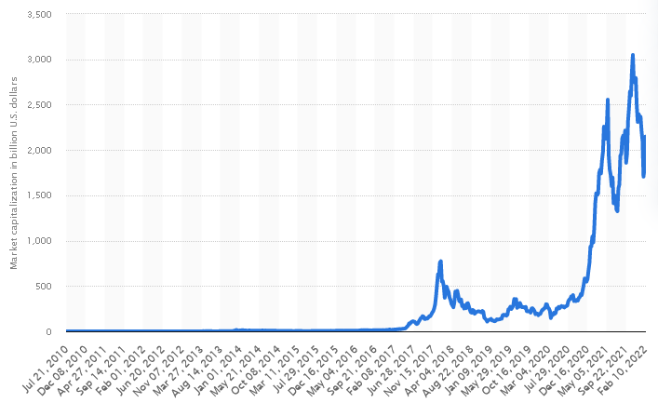
Figure 5 -Overall cryptocurrency market capitalization per week from July 2010 to February 2022 (in billion U.S. dollars).
The global user base of cryptocurrencies increased by nearly 190 percent between 2018 and 2020, only to accelerate further in 2021 (shown in figure 6). This according to calculations from various sources, based on information from trading platforms and on-chain wallets. The increase in demographics might initially have been caused by both a rise in the number of accounts as well as improvements in identification. More accounts in exchanges or wallets became systematically linked to an individual’s identity, which made it easier to estimate the minimum user numbers associated with accounts on each service provider. In 2021, however, crypto adoption continued as companies like Tesla and Mastercard announced their interest in cryptocurrency. On top of that, El Salvador became the first country in the world to accept Bitcoin as legal tender. These findings signify the normalcy of cryptocurrency in the global market and displays the opportunity to enhance operations with delicate matter such as vaccines associated with pharmaceutical companies.
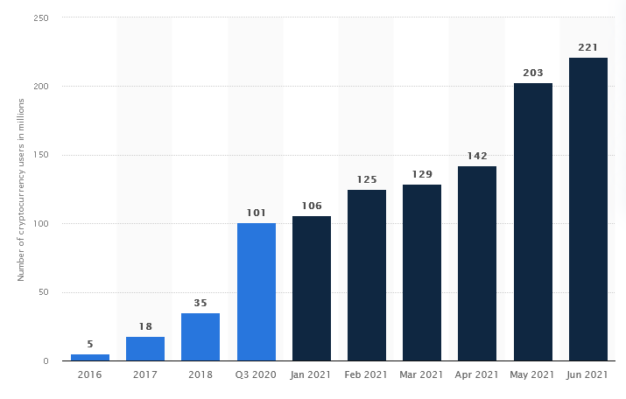
Figure 6 -Number of identity-verified crypto asset users from 2016 to June 2021(in millions).
As of February 14, 2022, over 547 million COVID-19 vaccine doses had been administered in the United States. This statistic shows the number of COVID-19 vaccine doses administered in the United States as of February 14, 2022, by state or territory. After only less than two years of Covid-19 being declared as a pandemic, the US has administered doses in a very high value. This finding dictates that demand of vaccines in a pandemic situation, and the willingness of customers to get vaccinated. Therefore, with the high vaccination rate, increasing internet penetration, and a high crypto usage, Bioviratech is deemed as a profitable business.
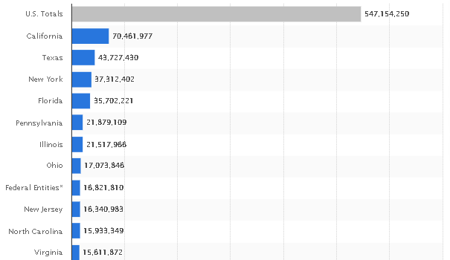
Figure 7 -Number of COVID-19 vaccine doses administered in the United States as of February 14, 2022, by state or territory.

6.0 Marketing Plan
The marketing plan of the company is stated in the table below.
Table 6 - Marketing Plan.
Product | The products of the company include the Bioviratech coin.
Price | The company aims to provide value to the less privileged; thus, the token price is kept at $1.00.
Place | The company seeks to operate globally. The marketing shall be done mostly on online channels.
Promotion | The company shall promote its offering on multiple networks. Social media marketing shall be applied by the company which would attract the target market of 21–45-year-olds who are regular users. Furthermore, the company would create attractive and engaging content to establish better customer relationship. Additionally, the company would use offline channels such as print media (posters) on key locations or newspapers, given the right opportunity, to attract relevant customers.  In terms of promotion, the company aims to provide discounts, and other promotional offerings such as getting a discount on a high amount of purchase.

6.1 Brand identity
In terms of brand identity, the company aims to associate itself with:
- Provider of opportunity for a balanced vaccination globally.
- High quality services in crypto.
- Elite experience in crypto and high profits on a long-term basis.
Furthermore, marketing professionals shall be hired to help in branding the business to maximise marketing potential.

6.2 Website
Similar to the competitors, the company shall have a website which includes all the necessary information regarding the business for the stakeholders. The content used shall be attractive and engaging to ensure maximum traffic.

6.3 Social Media
A professional shall be hired to handle social media tasks. The company shall use Facebook and other networks such as Instagram, Twitter, Reddit, Telegram etc. The content shall be posted and assessed regularly. The social media pages shall create attractive and engaging content to entice potential customers. Furthermore, new, or improved offerings shall be promoted on social media channels. Additionally, differentiating factors such as the theme, product making techniques, and usage of delicious sauces shall be highlighted on social media channels. Moreover, the company shall use sponsored social media posts to reach higher audience. The company can use different types of posts such as discussed in table 6.
Table 7 - Types of social media posts.
Type of Posts | Definition
Informational | These posts contain information for the followers regarding the service offerings of the website. Such posts can be used to build a relationship with the followers and increase engagement.
Collaborative | These posts contain another individual or group of people who do not belong to the company yet are in partnership with the brand to promote their services. These post can include celebrities or influencers etc., that can catch the attention of the users.
Promotional | These posts highlight the present or future promotional offers that the service is providing. These posts are designed to attract potential consumers, while these posts are also meant to trigger impulse buying within the target market.
Instagram TV | These posts are relatively long videos which may cover a range of topics.
New Brand Introduction | New brands that form an association with the company are highlighted in these kind of posts. The new offerings that the brands bring are also portrayed in these posts.
New Product Introduction | Any product that the company’s own collection or other brands introduce is shown in these posts. Pictures or videos may be used to promote the new product and its features.
Tutorial | These posts are meant to guide users on how to use the products/services that are offered by the company.
Awareness | These are notices such as the closure of stores, or out of stock/order of products/services.
General Awareness | These posts are meant to connect more with the audience as the company seeks to address general issues such as promoting local or international issues.
Societal issues | These posts are meant to form an emotional bond with the audience as the company posts off-topic about societal issues such as racism, fat-shaming, stereotypes etc.

6.4 Advertising
In terms of advertising the company has recognised four key channels which would be used to reach the target market, these include:
- Google paid ads
- Facebook and Instagram paid ads
- Social media account using hashtags
- Crypto Listings
- Local Papers/Posters (In small developing country communities).

6.5 PR and Influencer marketing
Traditional marketing techniques such as print media shall not be used aggressively by the company to reduce costs and spend effectively on efficient channels such as social media. However, posters shall be used in key locations to attract maximum relevant audience.
In addition to the above techniques, the company shall use social media influencers having a minimum of 20,000 followers to promote the services/ products of the company. Also, other small businesses including cafes etc., can be partnered with to create a higher influence in the community.

6.6 Opening/Re-launch marketing strategies
The company has recognised the following strategies as the ideal opening marketing measures for the business:
• Start Advertising before 3 months of ICO
• Create a hashtag
• Get creative with the promotional deals
• Tell a story/Give a sneak-peak
• Team up with local medical professionals and institutes
• Video teasers

8.0 Investors List
The potential outlets/mediums where the company can seek investment from are mentioned in table 7. Apart from the options discussed in the tables, local or international banks can also be considered for investment; however, the below mentioned options can provide enhanced value.
Table 7 – Investors List for the US.
AngelList Venture:  This platform connects businesses with potential angel investors. | https://www.angellist.com/
SBA:  This association is a governmental agency dedicated to providing funds to deserving applicants. | https://www.sba.gov/funding-programs/grants/grants-community-organizations
Crowdfunding options: Kickstarter and Indiegogo. | https://www.kickstarter.com/  https://entrepreneur.indiegogo.com/how-it-works/
Peer-to-Peer lending options: Lending Club and Prosper. | https://www.lendingclub.com/  https://www.prosper.com/
Equity Crowdfunding option: OurCrowd. | https://www.ourcrowd.com/
For the UK, the company can use the following platforms for investment.
Table 8 - Investor List for the UK.
https://fundinglondon.co.uk/funding/our-funds/ | This is a government fund aimed to help businesses such as Bioviratech.
https://equitiesfirst.com/hk/?gclid=Cj0KCQjw6-SDBhCMARIsAGbI7UjLZZD6HxRhCNX8q49Em6eBN4SVpSoNKAW9RZFAKUYiA8sUz2w1tGkaAlqiEALw_wcB | This company provides Progressive Capital.
https://www.criisp.io/?gclid=Cj0KCQjw6-SDBhCMARIsAGbI7UgiKyPvnlDnU2hoF0S8rXoQRbdzaLOwcB-RYOavQKqgkcO5zv1yi58aAnEQEALw_wcB | Relevant investors can be found on this website.
https://www.angelinvestmentnetwork.co.uk/investors-home | An effective network to find angel investors for the business.
https://get.pitchbook.com | An effective website to find investors relevant to the industry.

Contact Info
Website: www.bioviratech.com
Website: www.bioviratech.io
contact@bioviratech.com
Youtube: www.youtube.com/c/bioviratech.comofficial
Facebook: www.facebook.com/bioviratechofficial
Twitter: www.twittter.com/bioviratechcom1
Linkedin: hk.linkedin.com/company/bioviratechcom
Reddit: www.reddit.com/r/bioviratech_com
Telegram: www.t.me/bioviratechcomofficial
Blogger: bioviratech.blogspot.com
Instagram: www.instagram.com/bioviratechcomofficial
Github: https://github.com/bioviratech-com
Gitter: https://gitter.im/bioviratech-com
Discord: user : bioviratech#5073
Medium: medium@bioviratech
bioviratech.medium.com
https://medium.com/@bioviratech
Bitcointalk: username: Bioviratech
Bioviratech c/o Golden Life Holdings, 344-354 Gray's Inn road, London WC1X 8BP
UK shared office: Lithuanian and Bulgarian locations to be announced

